Practical-6

Name : Jadhav Harshvardhan Vijaysinh

Reg. No. : 2020BIT065

1 . Insertion Sort :

Code :

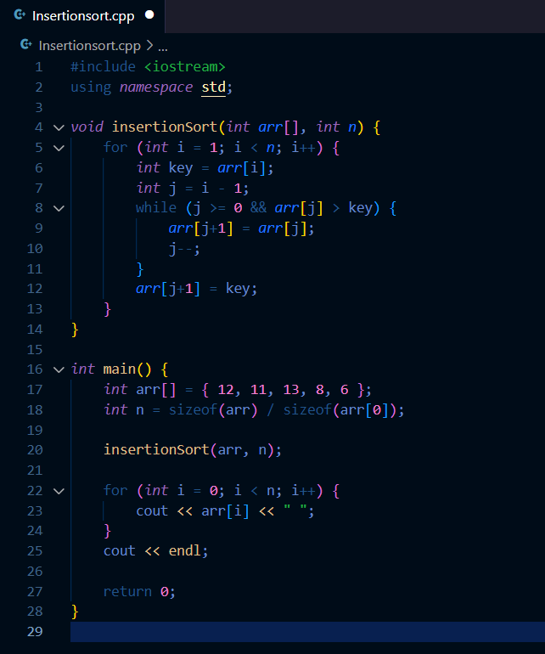

Output :

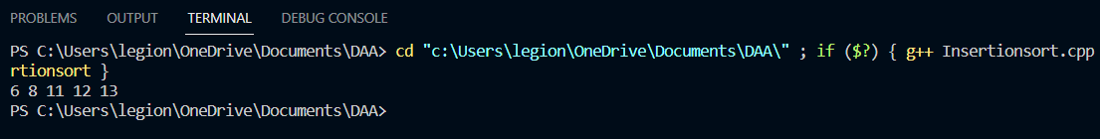

2 . Depth First Search (DFS) :

Code :

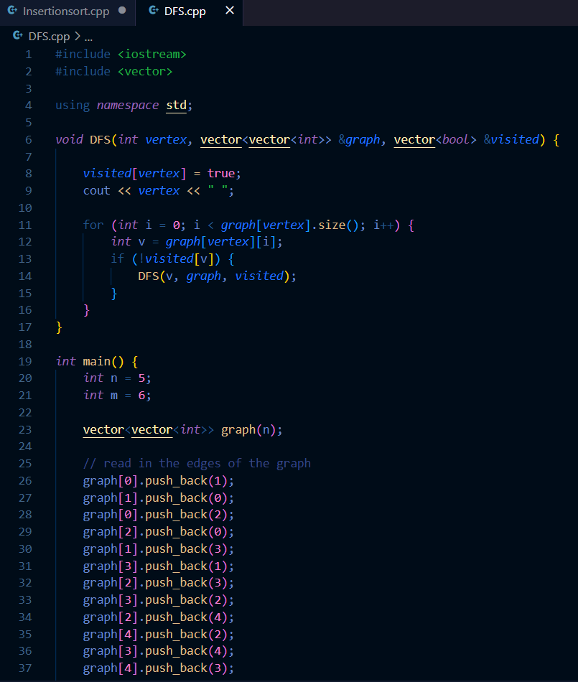

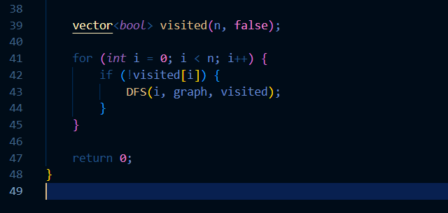

Output :

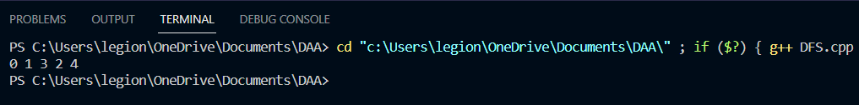

3 . Breadth First Search (BFS) :

Code :

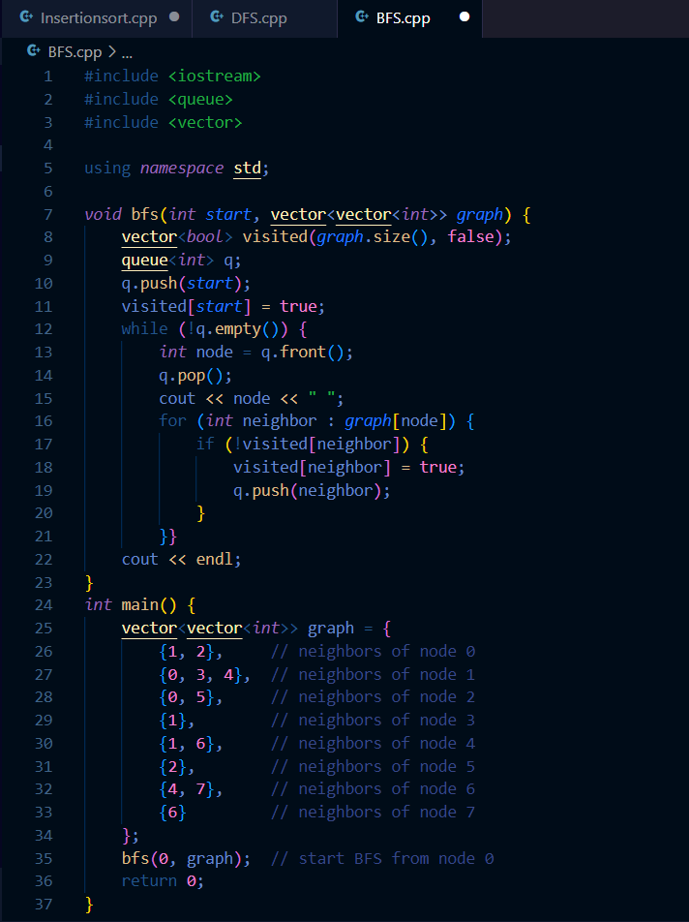

Output :

